**Raisa Nasir Pretty**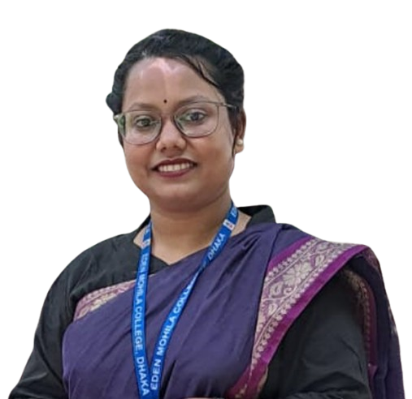

**Research & Communication Specialist**

**Present Address:** Khodeja Khatun Hall, Azimpur, Dhaka.

**Contact: +**8801868002585

**Email Address:** [raisapriety73@gmail.com](mailto:raisapriety73@gmail.com) **LinkedIn:** [linkedin.com/in/raisa-priety-0b4762330/](http://linkedin.com/in/raisa-priety-0b4762330/)

***Profile Summary:***

Proficient in utilizing qualitative and quantitative research methods to support strategic decision-making and drive innovative solutions. Adept at developing engaging content across various platforms, including reports, presentations, and digital media, to effectively convey insights and foster stakeholder engagement. Passionate about leveraging research to enhance organizational communication and contribute to meaningful outcomes.

***Career Objectives:***

As a motivated sociology graduate, I am eager to leverage my research and analytical skills in a dynamic organization. My goal is to contribute to projects that drive meaningful policy change and enhance the well-being of marginalized communities. I am committed to using my knowledge to foster positive social impact and empower individuals through effective outreach and engagement.

***Work Experience***

* **Internship at ABC Company** (2020-Present)

***Education:***

* **B.S.S. in Sociology** (2020-Present)

pulbish

**Institute Name:** Eden Mohila College, Dhaka

**CGPA:** Running

* **Higher Secondary Certificate (HSC- Humanities)** (2020)

**Institute Name:** Viqarunnisa Noon College, Dhaka

**GPA:** 4.75 (Out of 5)

* **Secondary School Certificate (SSC- Science)** (2018)

**Institute Name:** Shahebrampur High School

**GPA:** 4.72 (Out of 5)

***Certification:***

* Computer Fundamental Course from EDGE in 2024. ([Certificate](https://drive.google.com/file/d/1s3kX2k2Dtq9mVrcvQ23BuQXdxXiFuJdU/view?usp=sharing)).

***Key Skills:***

* Leadership with Intelligence.
* Teamwork and Cooperation.
* Well Analyst and Researcher.
* Communication with people.
* Creative Thinking.

***Computer Literacy:***

* **Operating System:** Windows
* **Software:** Internet Browsing, Email
* **MS Office:** MS Word, MS PowerPoint, Excel

***Co-Curricular Activities:***

* Member of the **“Boi-Brikkho”** at Eden Mohila College Branch.

***Language Proficiency:***

| Language Name | Reading | Writing | Speaking | Listening |
| --- | --- | --- | --- | --- |
| English | Fluent | Fluent | Fluent | Fluent |
| Bangla | Native | Native | Native | Native |